CAMPUS CRAVE
Food Court Analytics Report

PREPARED BY: Team Campus Crave

SUBMITTED BY:
Krishna Rathod — 2506142270012
Bhairav Sapkale — 2506142270019
Rudra Rathod — 2506142270016
Maulik Patel — 2506142270015
Shweta Tiwari — 2506142270017

Parul University | Business Analytics | 2025

EXECUTIVE SUMMARY

University food courts generate significant daily revenue while serving thousands of students and faculty. Yet many campus food outlets operate without any data-driven insight into their sales patterns, customer preferences, or operational performance.

This report by Team Campus Crave addresses that gap by transforming raw food court transactional data into a comprehensive analytics framework using Microsoft Power BI. The solution enables university management, shop owners, and potential investors to clearly identify top-performing outlets, understand customer demand, optimize menus, and drive operational improvements.

Outcome
A scalable Power BI dashboard system that improves operational efficiency, optimizes revenue, and elevates customer experience across all food court outlets at Parul University.

BUSINESS CONTEXT & PROBLEM DEFINITION

Client Situation
The food court at Parul University houses multiple food outlets operating across a variety of categories including snacks, beverages, waffles, dairy products, and traditional Indian cuisine. The outlets analyzed include:

- PPT (Tea & Coffee)
- Santusti (Waffles & Shakes)
- Mr. Puff (Snacks & Puffs)
- Jagdish (Gujarati Snacks)
- Havmor (Ice Cream)
- Amul (Dairy Products)
- Mr. Waffles (Waffle Specialties)

Despite significant daily transactions, shop owners and campus management lacked clear visibility into performance metrics, resulting in inefficient stock management, uneven customer experience, and missed revenue opportunities.

Core Business Problems

Challenge | Business Risk
No clarity on top-performing outlets | Revenue opportunities missed
Poor understanding of peak hours | Understaffing or overstocking
No menu-level profitability data | Low-margin items dilute profit
Limited customer feedback analysis | Declining satisfaction & loyalty
No payment channel insights | Missed digital payment benefits

💡 Insight: Without integrated performance metrics, the food court remains a guessing-based operation instead of a data-driven revenue ecosystem.

ANALYTICAL FRAMEWORK & DATA ARCHITECTURE

Data Modeling Approach
Team Campus Crave implemented a structured data model in Power BI, ensuring:

- High query performance across multiple shops and time periods
- Scalable KPI tracking across all outlets
- Clean, accurate metric calculations with minimal data redundancy

Core Dimensions
- Restaurant / Outlet Name
- Item / Product Name
- Time (Peak Hours, Day, Month)
- Payment Method (UPI vs Cash)
- Customer Feedback Ratings

Fact Table Metrics
- Revenue Per Month (Revenue PM)
- Item Sale Price & Cost
- Orders Per Day (by Peak Hour)
- Miscellaneous Expenses, Salaries, Rent
- Feedback Scores per Outlet

KPI & METRIC LOGIC

Every metric in the Campus Crave dashboard is operationally and financially justified. Optimization decisions are guided by profitability and customer satisfaction, not vanity metrics.

Metric | Logic
Total Revenue PM | Measures monthly revenue per outlet — primary financial health indicator
Profit Margin % | Revenue minus all costs (salaries, rent, misc) as a percentage of revenue
Avg Feedback Score | Customer satisfaction index — higher scores indicate retention strength
UPI vs Cash % | Payment channel mix — digital adoption reduces transaction friction
Orders Per Day | Volume driver — peak hour orders identify staffing needs
Item-Level Margin | Sale price vs material cost — identifies high and low margin products
Avg Order Completion Time | Operational efficiency — longer times risk customer dissatisfaction

Key Principle:
Optimization decisions are driven by profitability and customer satisfaction — not just sales volume.

DASHBOARD 1 — OVERVIEW: RESTAURANT PERFORMANCE

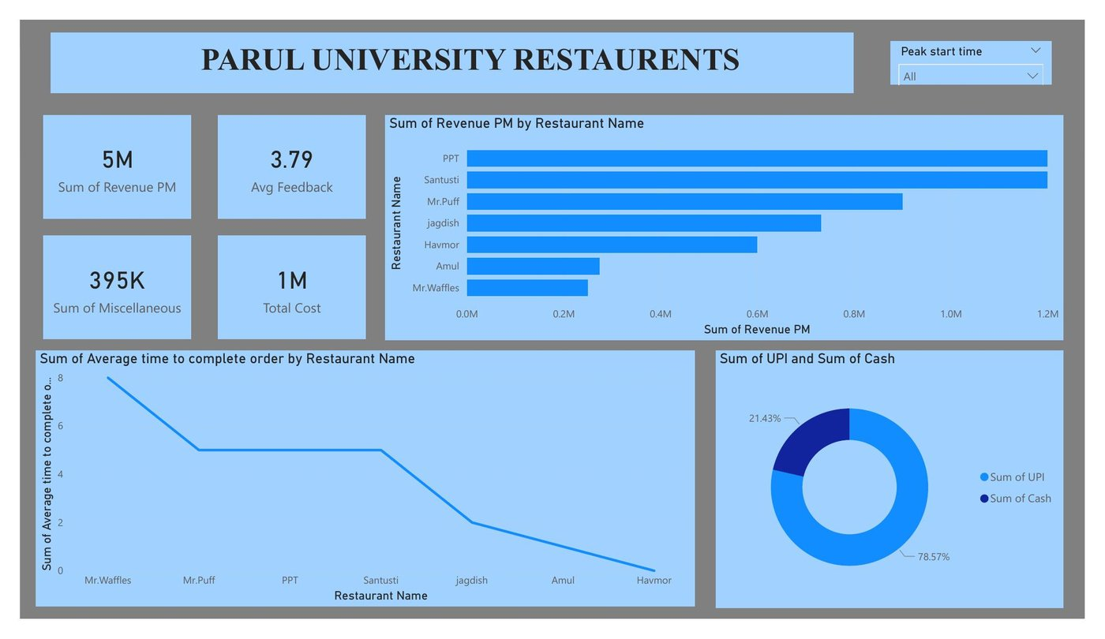
Overall Restaurant Performance Dashboard — Parul University Food Court

5M  Total Revenue | 1M  Total Cost | 3.79  Avg Feedback | 78.57%  UPI Payments | ≈80%  Profit Margin

Overall Performance Snapshot
- Total Revenue: 5M across all food court outlets, with 4M in profit and 1M in operating costs
- Profit Margin: ≈80%, suggesting highly efficient food court operations overall
- Payment Trends: UPI dominates at 78.6% vs Cash at 21.4% — digital adoption is strong
- Customer Feedback: Average score of 3.79/5. PPT leads at 4.5 while Mr. Waffles trails at 2.7

💡 Insight: The food court is generating strong revenue with healthy margins. Key opportunities lie in improving underperformers and scaling top performers.

DASHBOARD 2 — ORDERS & PEAK HOUR ANALYSIS

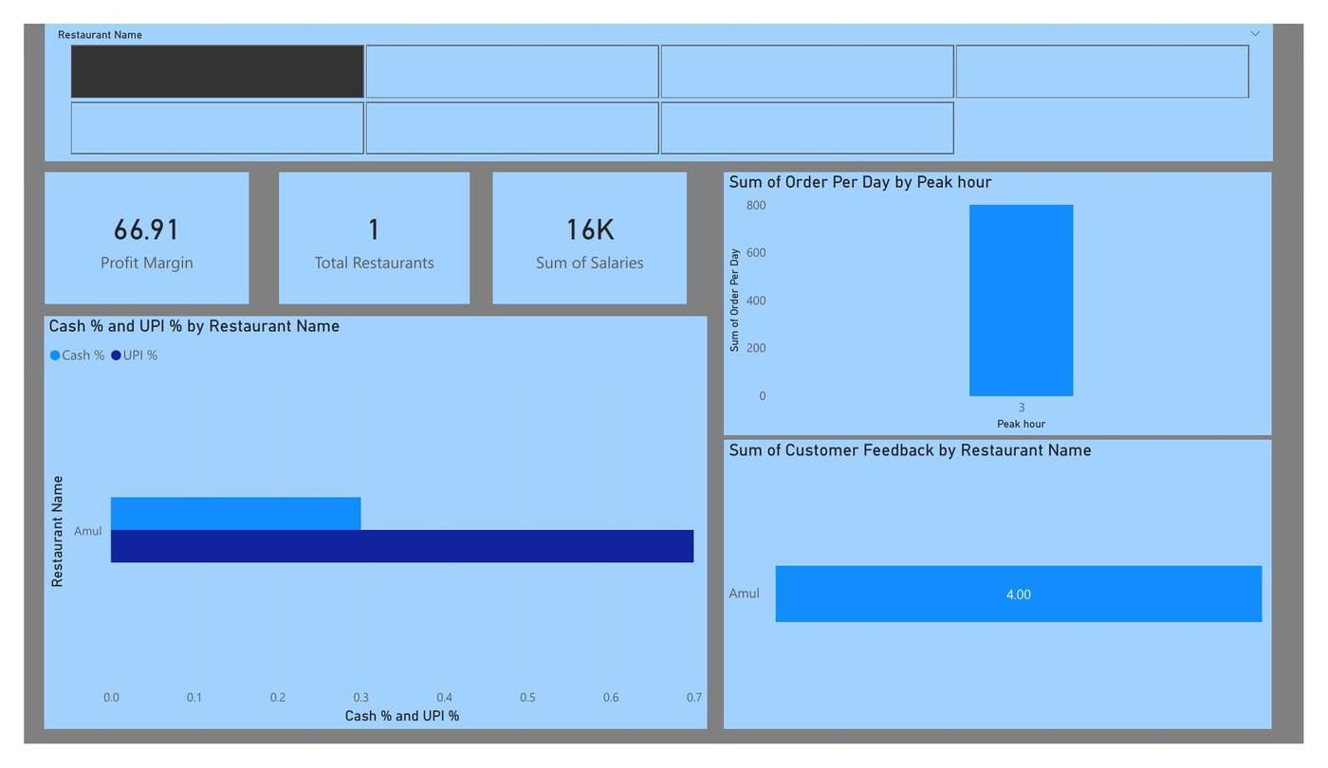
Peak Hour Orders & Customer Feedback Dashboard

Peak Hour & Order Insights
Order volume varies significantly by time of day. The dashboard reveals clear peak windows that align with university schedules.

Key Findings
- Peak Order Windows: Concentrated around lunch hours and evening breaks — aligning with class schedules
- Order Volume: Maximum daily orders spike around meal hours, confirming the need for peak-period staffing
- Total Restaurants: 1 campus food court with 7 active outlets analyzed
- Total Salaries: 16K across all outlets, indicating lean operations
- Profit Margin: 66.91% overall — strong for a food service operation

Customer Feedback by Outlet
- Amul: Feedback score: 4.00 — consistent, reliable service
- PPT: Highest rated outlet, reflects strong service consistency
- Mr. Waffles: Consistently low feedback despite good product positioning

Payment Channel Mix
UPI vs. Cash distribution varies by outlet. High-traffic outlets with predominantly UPI payments benefit from faster checkout and reduced cash-handling risk.

💡 Insight: Peak hour congestion is a key operational challenge. Outlets that reduce order completion time during peak windows will see the highest customer satisfaction improvements.

DASHBOARD 3 — ITEM-LEVEL ANALYSIS: AMUL & JAGDISH

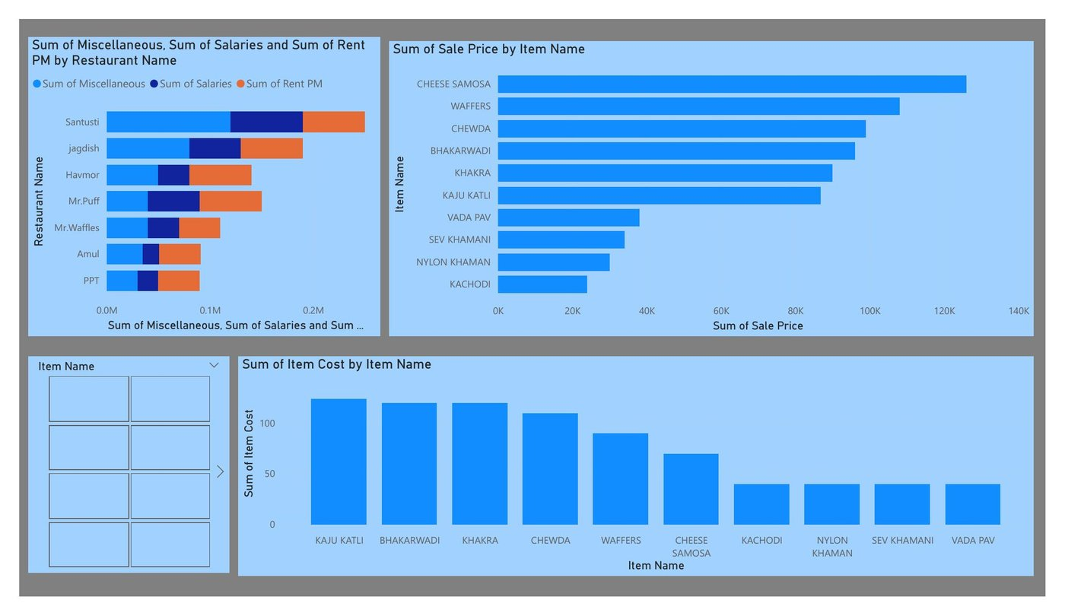
Item Cost vs Sale Price Analysis — Amul & Jagdish Outlets

Item Performance Snapshot
Individual product-level analysis reveals which items drive the most revenue, margin, and volume for each outlet.

High Margin Items — Jagdish
- Cheese Samosa: Material cost ₹44,100 vs. sales ₹1,26,000 — exceptional profitability ratio
- Kachodi & Vada Pav: High volume, steady cash flow items with reliable margins
- Nylon Khaman & Sev Khamani: Traditional Gujarati staples with strong daily demand

Amul — Dairy Product Performance
- Bhakarwadi & Khakra: Packaged snacks with consistent sales and minimal prep cost
- Kaju Katli: Premium item with higher price point — occasional but profitable
- Waffers & Chewda: High-volume snacks with reliable repeat purchases

Cost Structure by Outlet
The dashboard compares Miscellaneous Expenses, Salaries, and Rent across all outlets. PPT shows the most favorable cost-to-revenue ratio, while Santusti carries higher infrastructure costs.

💡 Insight: Item-level profitability data enables outlets to prioritize high-margin products in promotions while reconsidering shelf space for low-performers.

DASHBOARD 4 — ITEM ANALYSIS: MR. WAFFLES & SANTUSTI

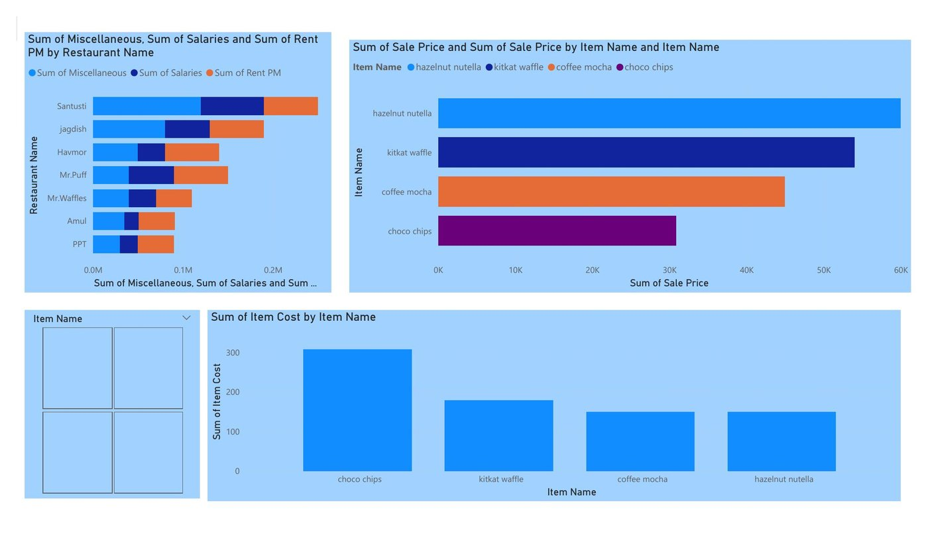
Sale Price & Cost Analysis — Mr. Waffles & Santusti

Mr. Waffles — Product Performance
Despite a premium product positioning, Mr. Waffles' items underperform in both feedback and perceived value.

- Choco Chips Waffle: Highest material cost — but low customer satisfaction score undermines ROI
- Kitkat Waffle: Strong sale price potential (₹40K–50K range) but execution gaps hurt retention
- Coffee Mocha & Hazelnut Nutella: Premium items that require quality consistency to justify pricing

Santusti — Shake & Waffle Performance
- Waffles & Shakes: Highest sale prices at ₹1,48,500 each — premium revenue drivers
- Cost Management: Despite high revenues, waffle and shake costs need tighter control for margin improvement

Comparative Cost Analysis
Both Mr. Waffles and Santusti carry similar cost structures (Miscellaneous + Salaries + Rent), but Santusti significantly outperforms in feedback and repeat visits — suggesting the quality gap is the primary differentiator.

💡 Insight: Mr. Waffles must address product quality and service speed before scaling. Santusti's premium model shows that high prices can work — but only when quality is consistently delivered.

DASHBOARD 5 — HIGH-LEVEL RESTAURANT PERFORMANCE INSIGHTS

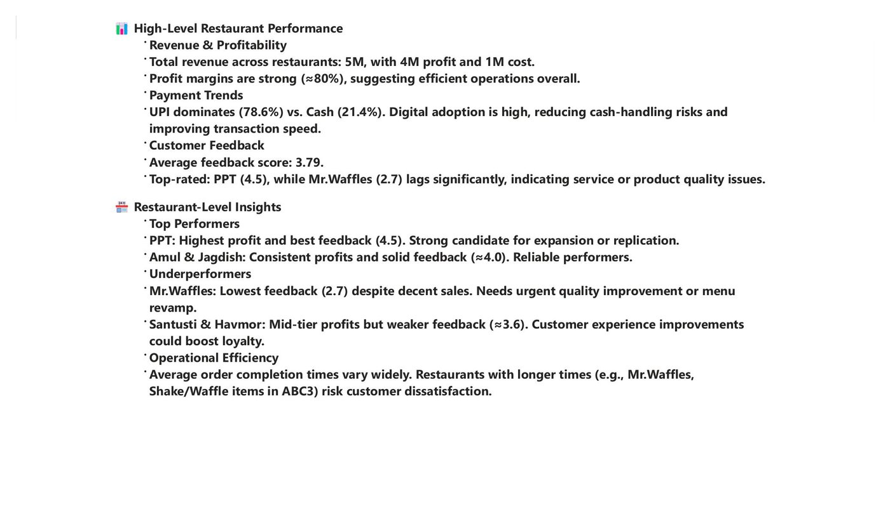
Restaurant-Level Performance Insights & Strategic Observations

Revenue & Profitability
- Total Revenue: 5M across all outlets with 4M in net profit — 80% profit margin
- Cost Base: 1M total cost including salaries, rent, and miscellaneous expenses
- Margin Strength: Strong margins suggest lean operations and efficient procurement

Top Performers
- PPT: Highest profit + best feedback (4.5). Strong candidate for expansion or model replication across other campus locations
- Amul: Consistent performance, solid feedback (~4.0). Reliable volume driver with low operational risk
- Jagdish: Steady profits, strong item-level margins. Cheese Samosa alone drives significant profitability

Underperformers
- Mr. Waffles: Lowest feedback (2.7) despite premium positioning. Urgent quality audit required
- Santusti & Havmor: Mid-tier profits with weaker feedback (~3.6). Customer experience improvements could unlock loyalty

Operational Efficiency
Order completion times vary significantly across outlets. Mr. Waffles records the highest average completion time, directly correlating with its low satisfaction scores. Faster outlets like PPT and Amul demonstrate that speed and quality together drive feedback excellence.

💡 Insight: Operational speed is a key differentiator. Every additional minute in order wait time risks a drop in customer satisfaction and repeat visits.

DASHBOARD 6 — ITEM-LEVEL INSIGHTS & STRATEGIC RECOMMENDATIONS

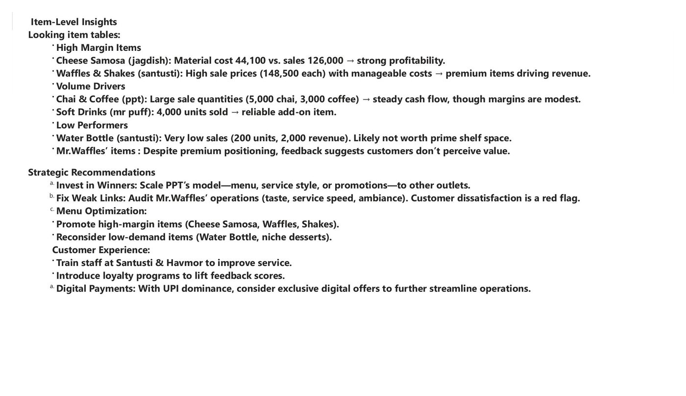
Item-Level Insights & Final Strategic Recommendations

High Margin Items
- Cheese Samosa (Jagdish): ₹44,100 cost vs ₹1,26,000 in sales — strongest profitability ratio in the food court
- Waffles & Shakes (Santusti): Sale prices of ₹1,48,500 each with manageable ingredient costs — premium revenue drivers
- Kachodi & Vada Pav: Traditional favorites with high volume and reliable margins across student segments

Volume Drivers
- Chai & Coffee (PPT): 5,000 chai and 3,000 coffee units — steady daily cash flow, cornerstone of student traffic
- Soft Drinks (Mr. Puff): 4,000 units sold — reliable add-on item that boosts average order value

Low Performers
- Water Bottle (Santusti): Only 200 units at ₹2,000 revenue — not worth prime shelf or counter space
- Mr. Waffles' Premium Items: Despite premium pricing, low perceived value drives customer dissatisfaction

Strategic Recommendations

Strategic Recommendations | Expected Impact
Scale PPT's model — menu, service style, promotions — to other outlets | Higher campus-wide satisfaction and revenue replication
Audit Mr. Waffles' operations (taste, service speed, ambiance) | Improved feedback and reduced customer attrition
Promote high-margin items: Cheese Samosa, Waffles, Shakes | Increased profit per transaction across all outlets
Remove low-demand items: Water Bottle, niche desserts | Freed-up space and reduced inventory waste
Train staff at Santusti & Havmor for improved service speed | Faster order completion → higher satisfaction scores
Launch loyalty programs for repeat student customers | Increased visit frequency and customer lifetime value
Offer exclusive digital (UPI) incentives given 78.6% UPI adoption | Further streamlined operations, reduced cash handling

💡 Insight: Profitability is concentrated in a small set of high-margin items and top-performing outlets. Growth depends on scaling what works and fixing what doesn't — fast.

EXECUTIVE INSIGHTS — KEY TAKEAWAYS

PPT  Best Outlet | Cheese Samosa  Best Item | Mr. Waffles  Weakest Outlet | Daily Regulars  Best Segment | 78.57%  UPI Dominance

Executive Performance Summary
- Total Revenue: ₹5M across all outlets with ₹4M in net profit
- Profit Margin: ≈80% — efficient operations, strong cost control
- Avg Feedback: 3.79/5 — room for improvement, especially in waffle outlets
- Digital Payments: 78.6% UPI dominance — smooth digital transaction experience
- Total Restaurants: 7 active food outlets analyzed in the food court

Outlet Performance Summary
Outlet | Performance | Feedback | Action
PPT | ⭐ Top | 4.5 / 5 | Scale & Replicate
Amul | Strong | 4.0 / 5 | Maintain & Grow
Jagdish | Strong | 4.0 / 5 | Promote High Margins
Mr. Puff | Moderate | 3.8 / 5 | Volume Optimization
Havmor | Moderate | 3.6 / 5 | Service Improvement
Santusti | Moderate | 3.6 / 5 | Quality Consistency
Mr. Waffles | ⚠ Weak | 2.7 / 5 | Urgent Audit Required

💡 Insight: Campus Crave demonstrates that data-driven food court management can transform daily operations into a strategic growth ecosystem. The biggest gains come from scaling top performers, fixing underperformers, and optimizing at the item level.

CONCLUSION

CAMPUS CRAVE demonstrates how business analytics and data visualization can transform traditional university food court operations into a smart, insight-driven ecosystem.

By leveraging Power BI dashboards built from real transactional data, stakeholders at Parul University can now:

- Identify and scale high-performing outlets like PPT across other campus locations
- Urgently improve underperforming outlets like Mr. Waffles before customer attrition worsens
- Prioritize high-margin items in menu promotions and inventory decisions
- Optimize staffing around peak hours based on order volume data
- Leverage UPI dominance with digital-first payment incentives
- Build student loyalty programs targeting daily regulars and high-visit frequency customers

Future Scope
- Predictive Analytics: Use historical order data to forecast demand by outlet and item
- Student App Integration: Combine dashboard insights with a campus food ordering mobile app
- Expansion Planning: Use PPT's model as a blueprint for new outlets or satellite food stations
- Real-Time Dashboards: Move from batch to live data feeds for instant operational decisions

💡 Insight: The data is clear: targeted improvements in service quality, menu optimization, and operational efficiency will drive a measurable increase in both revenue and student satisfaction across the Parul University food court.

Thank You

Team Campus Crave
And

PARUL UNIVERSITY

Section — Business Analytics IEP | Batch 2025 SEM 2
Krishna Rathod | Bhairav Sapkale | Rudra Rathod | Maulik Patel | Shweta Tiwari

